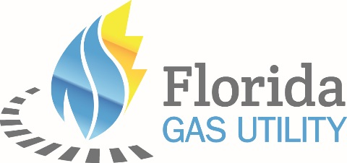

Wednesday, October 13th
11:30 – 1:00 pm Registration

1:30 – 5:00 pm General Session –
1:30 – 1:40 Opening Remarks – Thomas A. Geoffroy, FGU General Manager
Door Prizes
1:40 – 2:20 Doug John – John & Hengerer LLP – Federal Energy Regulatory Commission Update
2:20 – 3:20 Tim O’Connor – TECO Peoples Gas - Renewable Natural Gas
3:20 – 3:35 Break & Door Prizes
3:35 – 4:50 Dr. Jerry Parrish – Florida Chamber Foundation– Florida Economic Update
4:50 – 5:00 Session Wrap-up/Door Prizes

6:00 – 8:00 pm Evening Activities –
6:00 – 8:00 Cocktail Reception and Dinner

Thursday, October 14th
8:00 – 9:00 am Registration

9:00 – 11:30 am General Session –
Door Prizes
9:00 – 10:00 TBD
10:00 – 10:15 Door Prizes
10:15 – 11:30 Dr. Ken Morgan – Retired TCU Energy Institute – Energy & Climate: Who Can We Trust?
11:30 – 11:45 Wrap-up/Door Prizes

12:00 – 5:00 pm Afternoon Activities
Golf– TBD
Fishing – Trade Winds Deep Sea Fishing
Spa – Salamander Spa

7:00 – 10:00 pm Evening Activities –
7:00 – 10:00 Cocktail Reception and Dinner

Friday, October 15th
9:00 – 11:00 am Board of Directors Meeting –

Have a Safe Trip Home!

