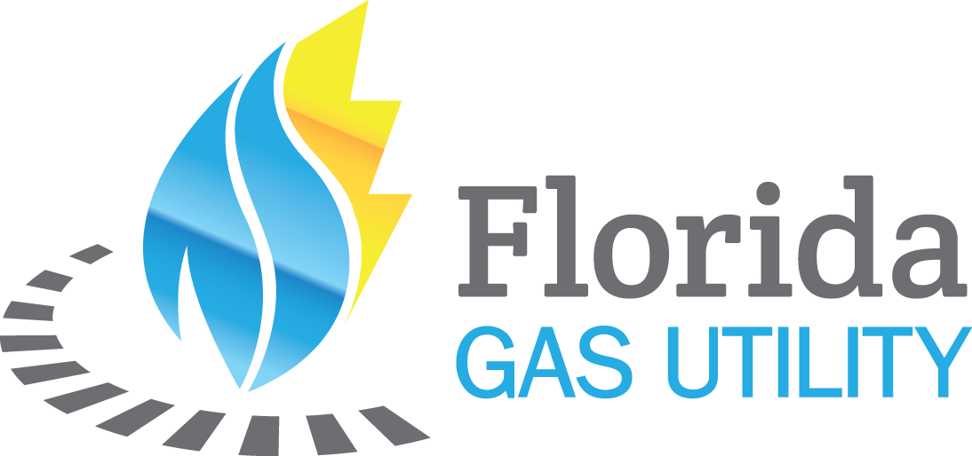

2026 Florida Gas Utility Annual Meeting :
Attendee List 9.10.2026

Last | First
Moreno | Evette
Bradley | Cathy
Cisneros | Jaiver
Barry | Patrick
Mullins | Drew
Milner | Bob
Long | William
Neily | Shawn
Smith | Tina
Lange | Justin
Sherrick | Steven
Rivera | Troy
Mortimer | Janice
Messick | Lori
Gilliland | Brian
Rutkin | Lew
Bradley | John
Popp | Rich
Burnett | Tim
Heston | John Paul
Vazquez | Jonathan
Devlin | Paul
Goepfert | Corey
Wagner | Bill
Batista | Fernando
Devlin | Charles
Barrera | Chrissy
Terry | Jason
Stephenson | Kate
Flores | Robert
Tillman | Christopher
Pence | Mike
Putnam | Allen
Stephenson | Matti
Ging | David
Clark | Kimberly
Garcia | Casey
Langille | Brian
Leon | Alex
Pollack | Bob
Branch | Billy
Maigon | Luis
Turner | Carley
Sowl | Sydney
Hilton | Clint
Alfaro | Daniel
Turner | Chris
Zembruski | Elizabeth
Williams | Jacob
Jackson | Steven
Rossetto | Walter
Gaddis | Fred
Stephens | Keith
Sherwood | Robert
Gonzalez-Jimenez | Luis
Anderson | Ethan
Anderson-Guest | Ethan
Klapesky | Cameron
Keon | Brian
Hancock | Bill
Bombard | Tory
Brown | Steve
McLean | Joseph
Lackey | Corey
Presto | Michael
Hancock | Keller
Jacobs | Seth
Stangl | Daniel
Futch | Jerry
Lievsay | Kevin
Stankiewicz | Justin
Masters | Jeremy
Simons | Luke
Snyder | Christophr
Nicholas | Emile
Smith | Emmett
Dulak | Morgan
Liberty | Ed
Mooney | Laura
Howell | Chris
Sedita | Paul
Dennis | Brett
DuPont | Joanie
Beauvais | Kadmiel
Bogatz | John
Mraz | Danny
Moore | Todd
Eysman | Oriana
Wilson | Zach
Summerall | Kevin
Centanni | Sam
Nicholas | Melissa
Miller | Clay
Campbell | Jude
Harris | Shawn
Briske | Andrew
Moore | Diane
Austin | Paul
Adedeji | Deji
Choukas-Bradley | James
Seeley | Matthew
Quoc | Mai
Halaway | Keneth
Reinhardt | John
McCord | Tom
Camp | Garth
Allyn | Matthew
Tyler | Lilly

